**\*Alter Command\***

**1) Modify:**

**a. Modify name column with varchar size 50.**

mysql> desc student;

+--------------+---------------+-------+------+---------+-------+

| Field | Type | Null | Key | Default | Extra |

+--------------+---------------+-------+------+---------+-------+

| rollno | int | YES | | NULL | |

| name | varchar(20) | YES | | NULL | |

| percentage | float | YES | | NULL | |

| address | varchar(50) | YES | | NULL | |

+--------------+---------------+-------+------+---------+-------+

mysql> alter table student modify name varchar(50);

Query OK, 0 rows affected (0.08 sec)

**Output:**

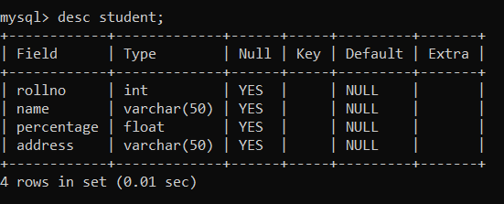

**b. Modify percentage column with double datatype.**

mysql> alter table student modify percentage double;

Query OK, 5 rows affected (0.09 sec)

Records: 5 Duplicates: 0 Warnings: 0

**Output:**

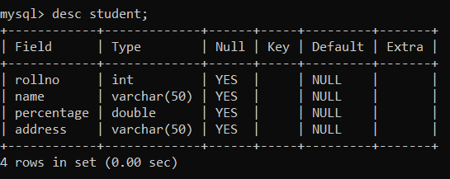

**2) Add Column:**

**c. Add mobileno column in given table.**

mysql> desc student;

+-------------+---------------+------+-----+---------+-------+

| Field | Type | Null | Key | Default | Extra |

+-------------+---------------+------+-----+---------+-------+

| rollno | int | YES | | NULL | |

| name | varchar(50) | YES | | NULL | |

| percentage | double | YES | | NULL | |

| address | varchar(50) | YES | | NULL | |

+-------------+---------------+------+-----+---------+-------+

mysql> alter table student add column mobileno int(15);

Query OK, 0 rows affected, 1 warning (0.03 sec)

**Output:**

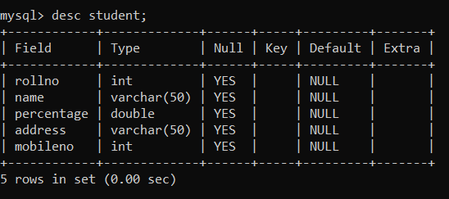

**d. Add state column in given table.**

mysql> alter table student add column state varchar(20);

Query OK, 0 rows affected (0.04 sec)

Records: 0 Duplicates: 0 Warnings: 0

**Output:**

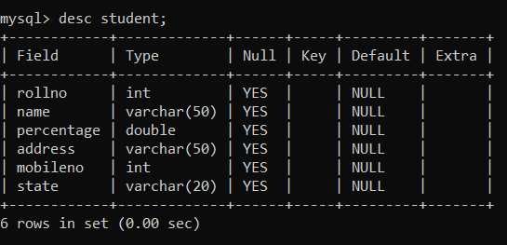

**3) Drop Column:**

**e. Drop column name mobileno from given table.**

mysql> desc student;

+-------------+---------------+-------+-----+---------+-------+

| Field | Type | Null | Key | Default | Extra |

+-------------+---------------+-------+-----+---------+-------+

| rollno | int | YES | | NULL | |

| name | varchar(50) | YES | | NULL | |

| percentage | double | YES | | NULL | |

| address | varchar(50) | YES | | NULL | |

| mobileno | int | YES | | NULL | |

| state | varchar(20) | YES | | NULL | |

+-------------+---------------+-------+-----+---------+-------+

mysql> alter table student drop column mobileno;

Query OK, 0 rows affected (0.07 sec)

**Output:**

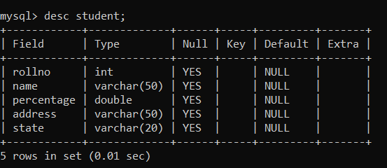

**4) Rename Column:**

**f. Rename percentage column name with stud_percentage.**

mysql> desc student;

+-------------+--------------+------+-----+---------+-------+

| Field | Type | Null | Key | Default | Extra|

+-------------+--------------+------+-----+---------+-------+

| rollno | int | YES | | NULL | |

| name | varchar(50) | YES | | NULL | |

| percentage | double | YES | | NULL | |

| address | varchar(50) | YES | | NULL | |

| state | varchar(20) | YES | | NULL | |

+-------------+--------------+------+-----+---------+-------+

mysql> alter table student change column percentage stud_percentage double;

Query OK, 0 rows affected (0.03 sec)

**Output:**

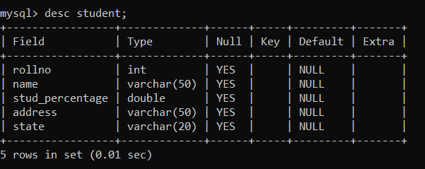

**g. Rename rollno column name with stud_id.**

mysql> alter table student change column rollno stud_id int;

Query OK, 0 rows affected (0.04 sec)

Records: 0 Duplicates: 0 Warnings: 0

**Output:**

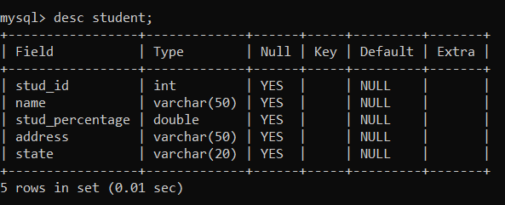

**\*Constraint\***

**1) Not Null Constraint:**

**a. Modify atleast two column of table student with not null constraint.**

mysql> desc student;

+--------------------+--------------+-------+-----+---------+-------+

| Field | Type | Null | Key | Default | Extra |

+--------------------+--------------+-------+------+---------+-------+

| stud_id | int | YES | | NULL | |

| name | varchar(50) | YES | | NULL | |

| stud_percentage | double | YES | | NULL | |

| address | varchar(50) | YES | | NULL | |

| state | varchar(20) | YES | | NULL | |

+--------------------+--------------+-------+------+---------+-------+

mysql> alter table student modify column stud_id int not null;

Query OK, 0 rows affected (0.15 sec)

Records: 0 Duplicates: 0 Warnings: 0

mysql> alter table student modify column name varchar(50) not null;

Query OK, 0 rows affected (0.12 sec)

Records: 0 Duplicates: 0 Warnings: 0

**Output:**

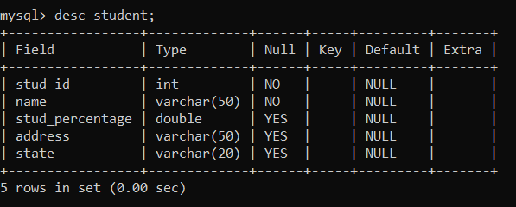

**b. Create table persons with using not null constraint.**

mysql> create table persons(ID int not null,

-> LastName varchar(255) not null,

-> FirstName varchar(255) not null,

-> Age int);

Query OK, 0 rows affected (0.04 sec)

**Output:**

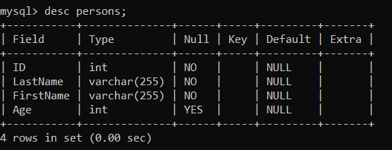

**2) Create table student1 which contain id, name, class, age, city columns in given table. Add following constraint.**

**a. Not null constraint on Name and Age.**

**b. Primary key on Id.**

**c. Check whether age is between18 to 26.**

**d. Check whether class is either FY, SY, TY.**

mysql> create table student1 (Id int primary key,

-> Name varchar(20) not null,

-> Class varchar(20) check (Class='FY' or Class='SY' or Class='TY'),

-> Age int not null check (Age>=18 and Age<=26),

-> City varchar(20));

Query OK, 0 rows affected (0.06 sec)

**Output:**

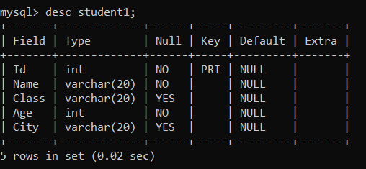

mysql> insert into student1 values(1,'Samiksha Chougule','TY',21,'Kolhapur');

Query OK, 1 row affected (0.04 sec)

